Kainan Dos Santos

Introdution:

This is a student database and create tables for student personal records and student academic record.

We used Acess, Turnitin ang GiHub.

Methodology:

We used SQL query select data from both tables by merging it into one query.

Results:

I Applied in different SQL queries of complex format, so I got flexibility with the usage. It was very good.

Conclusion:

With this work I got a new knowledge about table and it can help me in the future.

This is the first table that I created, there a put Name, Student Id, Age, Year and Country.

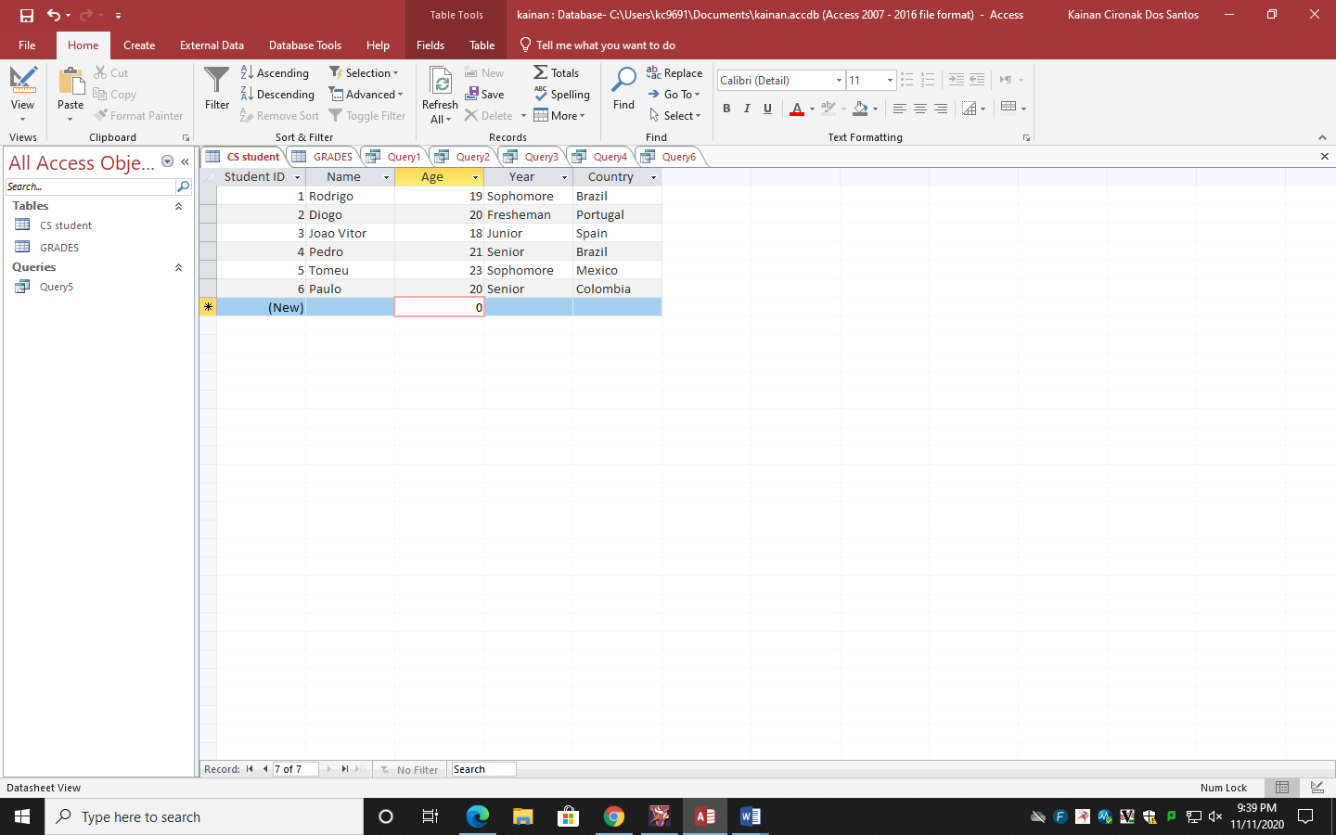

This is the second table, I put some information about GPI and Major.

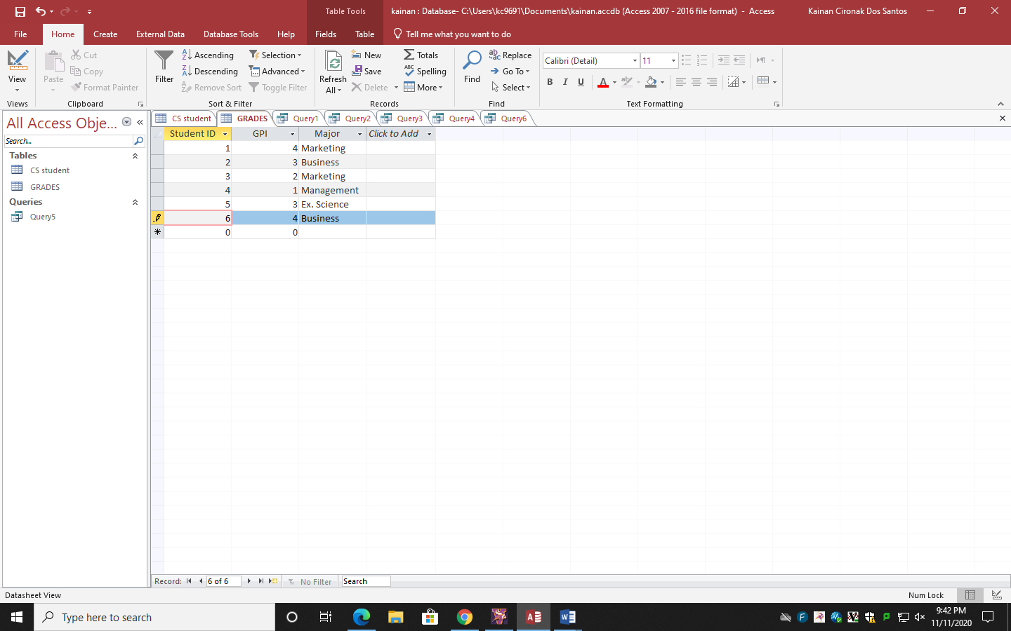

After I create this 2 first table, I did a mix of both and I created 5 tables

